**Ray Tracing Report:**

I used the method that is “for each pixel of the screen”, so in this method, all pixels in the image are controlled and processed.

I usually used numpy library because it makes array controls and mathematical processes easy. Therefore, I usually use numpy library in my main code and the methods.

In main code, I use a tricky_point to find true intersection point and do not to find same previous nearest intersection point, so I use an eligible value (10^-5) for tricky_point to shift.

Methods:

* create_sphere(N):

It provides to create spheres by using information that taken from users. Return array of spheres.

* normalVector(vector):

It provides to find the normal of the vector.Return the normal of the vector.

* reflectionVector(vector, normal):

It provides to find reflected vector of the vector by using the normal (normal of surface). Return the reflection vector of the vector from the surface.

* intersectionSphere(center, radius, ray_origin, ray_direction):

It provides to detects intersections between a ray and a sphere. Return the distance from the origin of the ray.

* nearest_intersected_object(objects, ray_origin, ray):

It provides to find the nearest object that a ray intersects. Return nearest object and its distance.

Test:

* Test1:

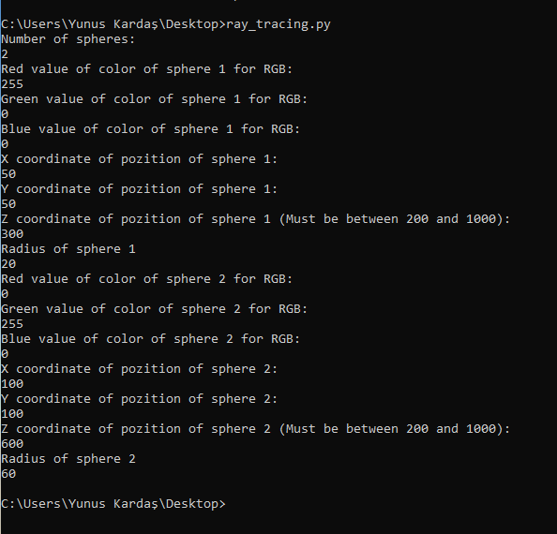

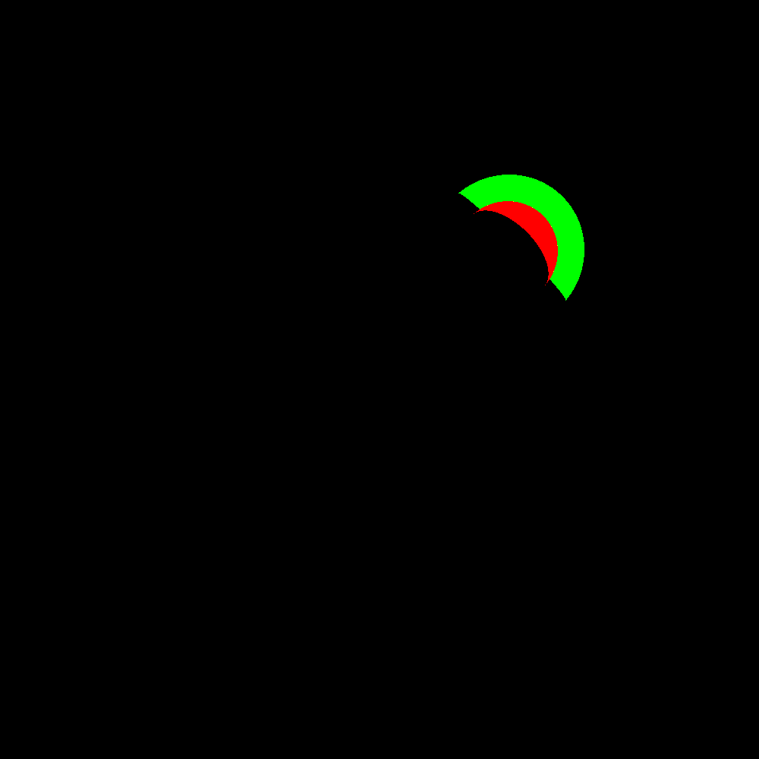

* Test2:

